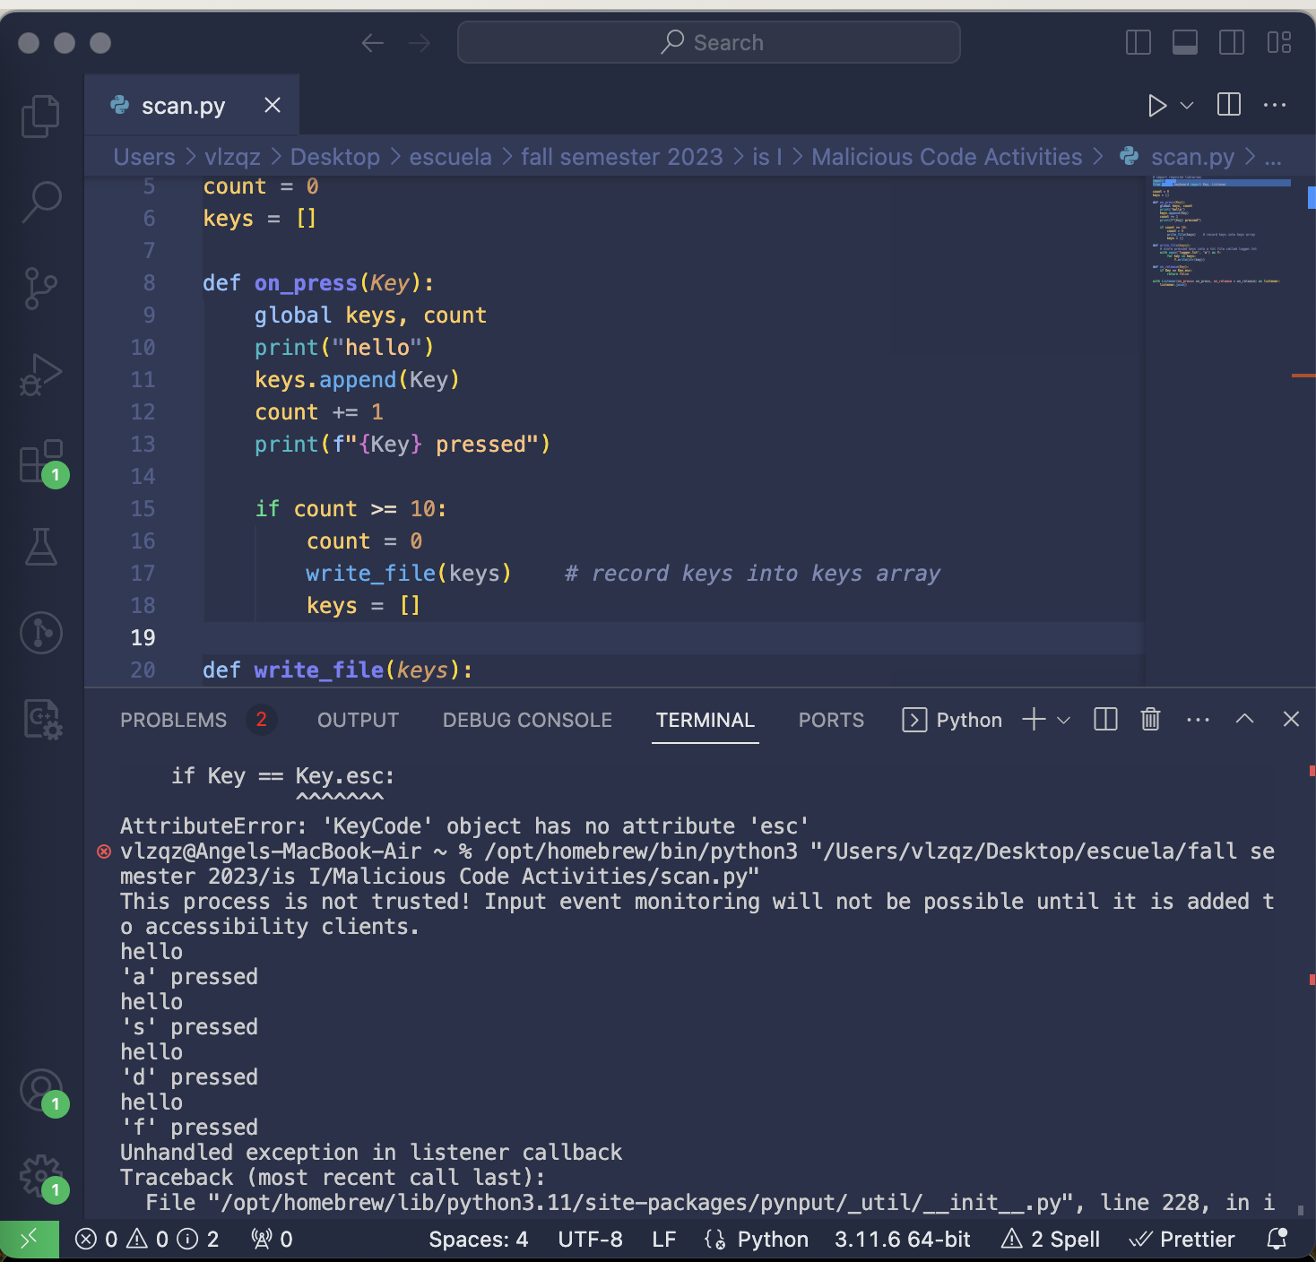

When initiating the python script, we can see that some keys are recorded onto the terminal. However, my mac settings prevent the script from storing the pressed keys into the txt file. I have tried various ways to disable my input monitoring settings. However, nothing there are difficulties with executing this script as well as attempting to find the python exe file within the input monitoring settings to enable my keystrokes to be recorded.